

**T.Y. B. Tech. MINI PROJECT-I REPORT**

**On**

**DISEASE(DIABETES) PROGRESS PREDICTION**

Submitted by,

**APOORV WAGHMARE**

Project Guide:

**Prof. ARTI KHAPARDE**

**Year: 2019 -2020**

**School of Electronics and Communication Engineering**

**MIT World Peace University, Pune**





**School of Electronics and Communication Engineering**

**MIT World Peace University, Pune**

**CERTIFICATE**

(16pt, Bold, Upper Case)

This is to certify that the T.Y. B. Tech.Mini Project-I entitled

*(2 Blank Spaces)*

**DISEASE(DIABETES) PROGRESS PREDICTION**

work has been carried out successfully by

**APOORV WAGHMARE(S1032170508)**

during the Academic Year 2019 - 2020 in partial fulfillment of their cmyse of Mini Project-I for Third Year Electronics and Communication Engineering as per the syllabus prescribed by the MIT World Peace University Pune

Guide Mini Project Coordinator

Head of School

MIT World Peace University, Pune

School of Electronics and Communication Engineering

Project Report Contents

|  |  |  |  |
| --- | --- | --- | --- |
| Sr no | Contents | Percentage Contents of Report | Remarks |
| 1 | Title | 5 % | Detail Index |
| Certificate |
| Acknowledgement |
| Index |
| List of Figures |
| List of Tables |
| List of Abbreviations |
| 2 | **Chapter 1** | 10 % | Scope of Project |
| Introduction |
| Scope and Objectives |
| 3 | **Chapter 2** | 10 % | References of what has been done before/published. |
| Review of the related Literature |
| Present Scenario |
| 4 | **Chapter 3** | 20 % | Most Important |
| System schematic and specification |
| Block Diagram |
| Flow Chart Algorithm |
| Complexities Involved | (In my work) |
| 5 | **Chapter 4** | 40 % |  |
| System Design |
| 6 | **Chapter 5** |
| Implementation, Testing and Debugging | Physical Verification of the system |
| 7 | **Chapter 6** | 15 % | Result sheets  Conclusion |
| Results, Conclusion and Future Scope |
| 8 | Bill of Material |  | Datasheets only of specific IC's. |
| References |
| Datasheets |

**\*Guidelines for Mini Project Report Preparation\***

1. Font used for entire report should be Times New Roman
2. For title page of each chapter use Font Size 16 pt. Bold
3. For headings on internal pages of report use Font Size as 14 pt. Bold
4. For sub headings use Font Size as 12 pt. Bold
5. All paragraphs on each page should have Font Size as 12 pt., Normal, spacing 1.5 and justified on both sides of margins
6. Use single sided printing on each page for report
7. Print three hard copies of the report for submission and CDs
8. Use Spiral Binding for Report

**Contents**

1. Introduction
2. Motivation
3. Basic Block Diagram
4. Software Description
5. Testing
6. Challenges and other initiatives
7. Results and Conclusions
8. References
9. Schematic Diagram

**List of figures**

1. Block diagram
2. Prediction Model
3. Output percentage vs day graph

**CHAPTER 1:**

1. **Introduction:**

Before any new medicine is introduced in the market, it is first tested on rodents in facilities .My Project was to build an application which will show how disease have progressed with respect to time for different antidotes in rats. The model used for this prediction is built using data of healthy rats and diabetic rats.

1. **Scope & Objectives:**

The objective of this project was to explore the use of machine learning in the field of medical. My application application can be used to keep a track of how diabetes is progressed with respect to time when any new antidote is given to diabetic rats. This will help us to compare the effect of different drugs and choose the best drug which shows quick and long lasting results.

**CHAPTER 2:**

1. **Review of the Literature survey:**

Various researches have been made by different researchers in developing this project. However, they serve a different application and have different technologies implemented. Various links for the research have been given in the bibliography section of the report.

2. **Present scenario:**

As of today, various types of advancements have taken place and more are taking place in the field of medical with the use of machine learning and artificial intelligence. This helps us to build better machinery, make better drugs and find cheaper and better solutions to treat different diseases.

**CHAPTER 3:**

**1. Training the Model:**

* 1. **Data required:**

The data required to train the model is weekly body weight and blood glucose level of healthy rats and diseased rats who have not been treated with any antidotes

The data of the diseased rats have to be with the percentage of disease. These disease percentage values are assigned by experts.

This data is used for training and later the trained model can be used to predict diabetes progression of any rat which is injected to any antidote.

**SAMPLE DATA:**

**Type Mouse Day BodyWeight BloodGlucose Percentage**

**0 NC 1 0 293.0 101.0 0.0**

**1 NC 1 7 299.0 109.0 0.0**

**2 NC 1 14 298.0 113.0 0.0**

**3 NC 1 21 305.0 105.0 0.0**

**4 NC 1 28 313.0 98.0 0.0**

**Type Mouse Day BodyWeight BloodGlucose Percentage**

**0 DC 7 0 268.0 359.0 30.0**

**1 DC 7 7 282.0 325.0 27.0**

**2 DC 7 14 280.0 311.0 30.0**

**3 DC 7 21 265.0 337.0 34.0**

**4 DC 7 28 260.0 368.0 55.0**

The above data is a small chunk as sample from the data set used to train the model.

NC stands for NO CONTROL representing the category of healthy rats.

DC stands for DISEASE CONTROL representing category of rats that are affected by diabetes but are not treated with any medicine.

* 1. **ALGORITHM USED:**

I have used multiple linear regression to train my machine. I have fitted the best possible surface in the data used for training. After training the function of this surface is used to predict the progression of diabetes in any diabetic rat treated with any antidote.

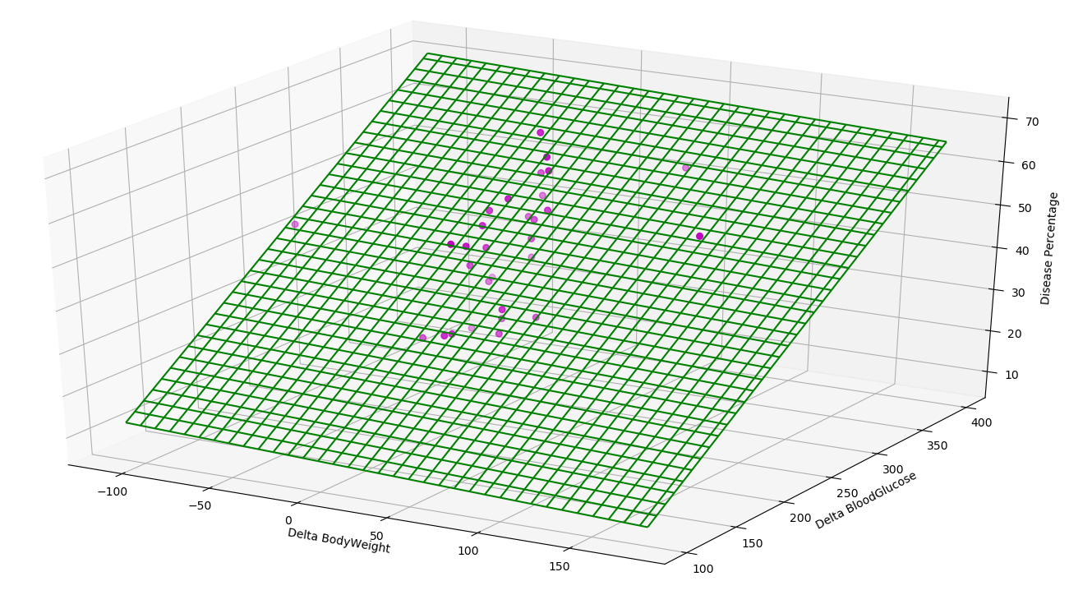

This is how the trained model looks when plotted in 3D.

**CHAPTER 4:**

**1. Block diagram:**

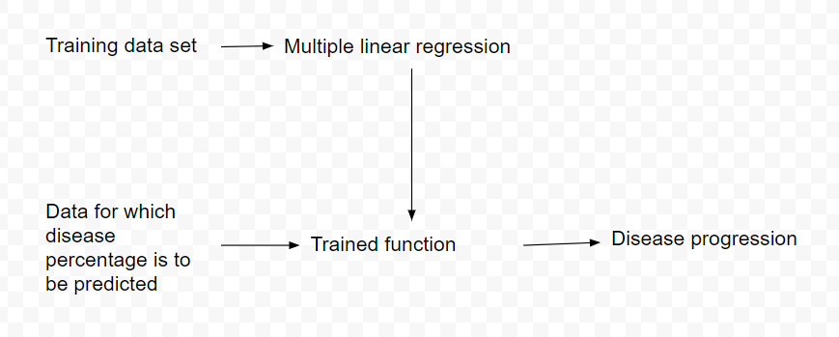

Fig E: Block diagram

**CHAPTER 5:**

**1. Testing**

The testing of the trained model was done by comparing the result of the trained function with the already available values specially kept for training. A try test was also done by comparing the disease progression of diseased rats and rats injected with antidotes.

The error of 5% - 6% appears in predicted disease percentage but not more than that.

I think this prediction is pretty accurate.

**5. Challenges and other initiatives**

The main challenge in this project was the fact that unlike healthy human beings the body weight of healthy rats keeps increasing with respect to time. On an average the body weight of diabetic rats is less than healthy rats and their weight remains constant of decreases with respect to time.

Blood glucose of healthy rats is way less than that os diabetic rats.

Keeping these two factors in mind I have designed a formula which compares the rate of change of body weight of healthy and diseased rats and also compares blood glucose level of diseased and healthy rats.

**CHAPTER 6:**

**1 Results and Conclusions:**

The result of the project is we can plot and compare the disease progression of any diabetic rat injected with any antidote with respect to time. This will help us to compare and finalize the best possible drug.

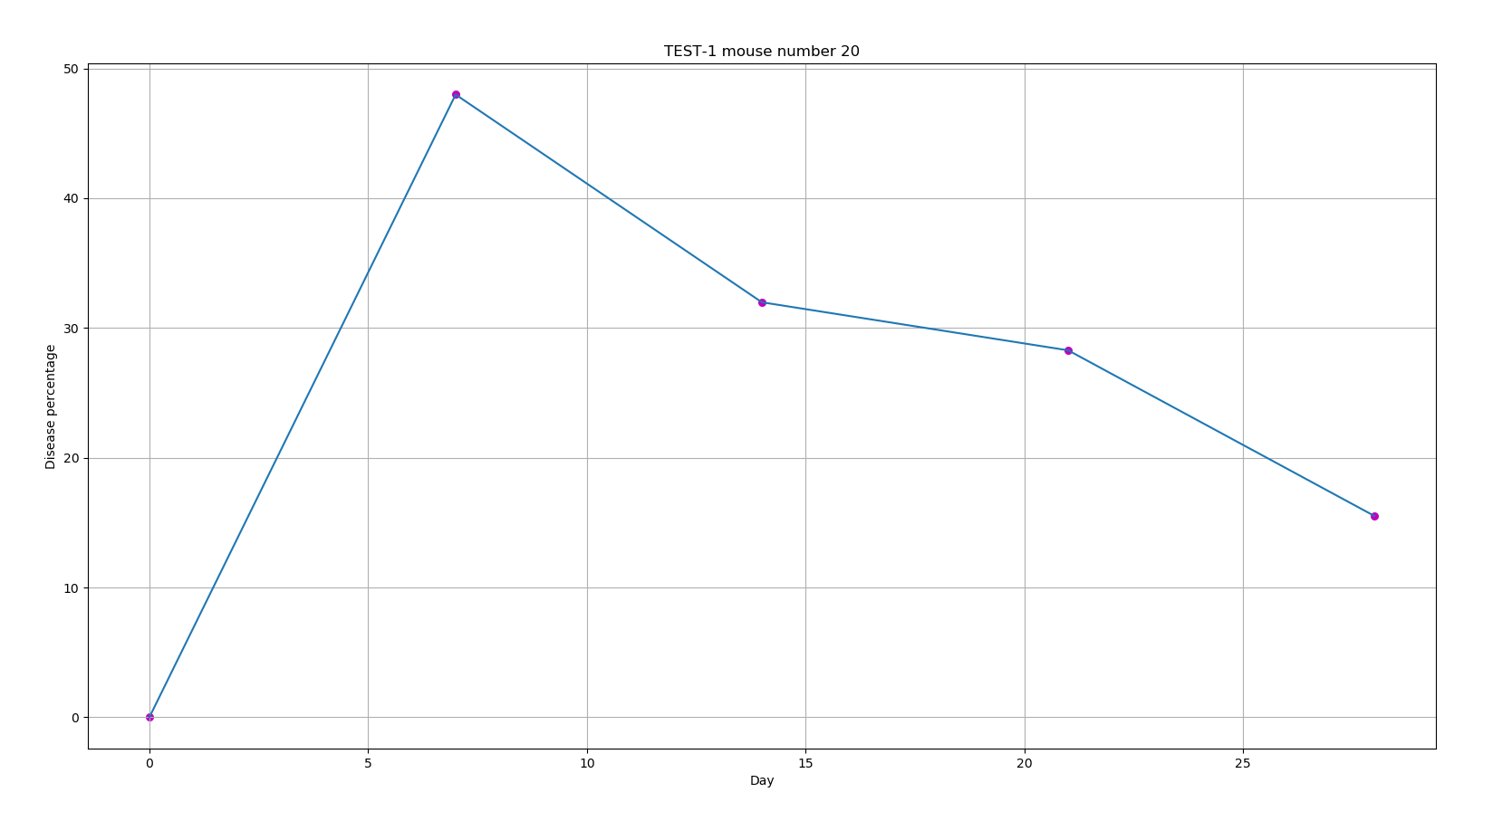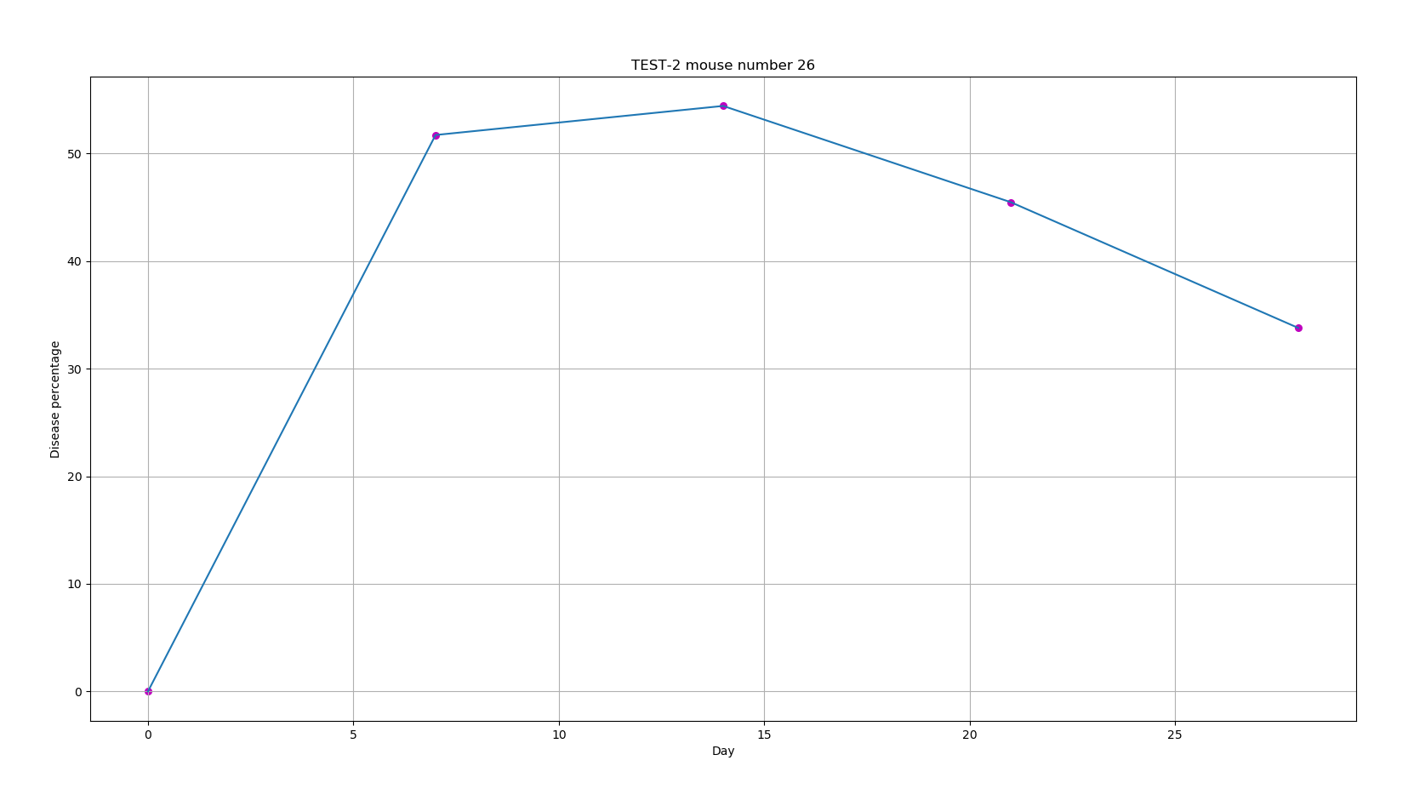

Above two graphs show percentage of disease with respect to time for two different rats that are treated with different antidotes.

**2 Future Scope:**

Use of machine learning and artificial intelligence is increasing in the field of medical. This project is also aims in that direction. In future an application like this can be used for comparing and determining the best medical assistance.

**CHAPTER 7:**

**References**

I have studied regression from the references listed below. After studying I have myself derived the function to find the best fit plane and line for training data.

The formula used for considering the variation of weight in rats and difference in blood glucose value was also derived by me.

[1] Fundamentals of mathematical statistics, author S.C. GUPTA, V. K. KAPOOR

I also used the link for extra information on diabetes in rats and other parts of myproject.

1. https://www.statisticshowto.datasciencecentral.com/probability-and-statistics/regression-analysis/
2. https://www.statisticssolutions.com/what-is-linear-regression/
3. https://diabetes.diabetesjournals.org/content/64/3/1057